Acceptance tests   
Acme Chorbies 2.0

|  |  |
| --- | --- |
| ****Development team**** | |
| **Identifier** | GrupoDP-28839708 |
| **Members** | Acha Burgos, Álvaro  Iglesias Pérez, Daniel  Gavira González, José Manuel  Rodrígez Martín, Javier  Roldán Sánchez, Pablo  Ronda Lucena, Arturo |
| **Testing team** | |
| **Identifier** | Acmesome42 |
| **Members** | Bujalance Muñoz, Alberto  Gamero Monge, Alejandro  Martín Gordillo, Álvaro  Troncoso Correa, Julio  Vázquez Zambrano, Pablo  Villanueva Orgaz, Andrés |
| **Indexing data** | |
| **Test designers** | Acha Burgos, Álvaro  Ronda Lucena, Arturo |
| **Testers** | List the people who have conducted the tests. |
| **Notes** |  |

Table of contents

Use case 1 Internalization 3

Use case 2 Welcome Page 3

Use case 3 Login 4

Use case 4 Register 4

Use case 5 List of Chorbies 5

Use case 6 Profile 5

Use case 7 Search Template 6

Use case 8 Ban/Unban a chorbi 7

Use case 9 Configurations 8

Use case 10 Like 9

Use case 11 Chirp 9

Use case 12 Events in less than 1 month 11

Use case 13 All events 11

Use case 14 Manage events 12

Use case 15 Register to an event 13

Use case 16 Un-register to an event 13

Use case 17 Your events. 14

Use case 18 Update monthly fees 14

Use case 19 Broadcast chirps 15

Use case 20 List of Chorbies who have liked him or her 15

Use case 21 Manage credit card 16

# Use case 1 Internalization

Description

The system must be available in English and Spanish.

Access

Press en or es button to switch between English or Spanish language.

Tests

|  |  |
| --- | --- |
| **Test <#1>** | |
| **Description** | Check that all cases are available in both language. |
| **Expected** | Texts and errors must have been translated. |
| **Outcome** |  |
| **Notes** |  |

# Use case 2 Welcome Page

Description

See a welcome page with a banner that advertises Acme projects, including Acme Pad-Thai, Acme BnB, and Acme Car’n go! The banners must be selected randomly.

Access

Just enter the application.

Tests

|  |  |
| --- | --- |
| **Test <#1>** | |
| **Description** | Realise that banners are been displayed with references to other acme projects. |
| **Expected** | A banner with references to other acme projects. |
| **Outcome** |  |
| **Notes** |  |

# Use case 3 Login

Description

Login to the system using his or her credentials.

Access

Select login option in the menu bar.

Tests

|  |  |
| --- | --- |
| **Test <#1>** | |
| **Description** | Log on with a non-banned user with correct credentials. |
| **Expected** | You must be logged and be able to see the welcome page. |
| **Outcome** |  |
| **Notes** |  |

|  |  |
| --- | --- |
| **Test <#2>** | |
| **Description** | Log on with a banned user with correct credentials. |
| **Expected** | You mustn’t be logged. |
| **Outcome** |  |
| **Notes** |  |

# Use case 4 Register

Description

Register to the system as a chorbi. As of the time of registering, a chorbi is not required to provide a credit card. No person under 18 is allowed to register to the system.

Access

Select register option in the menu bar.

Tests

|  |  |
| --- | --- |
| **Test <#1>** | |
| **Description** | As a new user complete register form, and login. |
| **Expected** | You must be logged and be able to see the welcome page. |
| **Outcome** |  |
| **Notes** |  |

|  |  |
| --- | --- |
| **Test <#2>** | |
| **Description** | Register with all fields blank. |
| **Expected** | Errors will appear at each field with annotations about the errors. |
| **Outcome** |  |
| **Notes** |  |

|  |  |
| --- | --- |
| **Test <#3>** | |
| **Description** | Register with some fields blank. |
| **Expected** | Errors will appear at each field with annotations about the errors. |
| **Outcome** |  |
| **Notes** |  |

# Use case 5 List of Chorbies

Description

Browse the list of chorbies who have registered to the system.

Access

Login the application and select list chorbies in the menu bar.

Tests

|  |  |
| --- | --- |
| **Test <#1>** | |
| **Description** | Check that the list of chorbies is displayed correctly. |
| **Expected** | A list of chorbies who have registered to the system. |
| **Outcome** |  |
| **Notes** |  |

# Use case 6 Profile

Description

Change his or her profile.

Access

Login the application and select my profile in the menu bar and at the bottom page select edit profile.

Tests

|  |  |
| --- | --- |
| **Test <#1>** | |
| **Description** | Check that the profile is displayed correctly and the edit function work as expected. |
| **Expected** | Profile must have been changed. |
| **Outcome** |  |
| **Notes** |  |

|  |  |
| --- | --- |
| **Test <#2>** | |
| **Description** | Fill profile form fully blank. |
| **Expected** | Errors must appear next to each text area. |
| **Outcome** |  |
| **Notes** |  |

# Use case 7 Search Template

Description

Browse the results of his or her search template as long as he or she’s registered a valid credit card. Note that the validity of the credit card must be checked every time the results of the search template are displayed. The results of search templates must be cached for at least 12 hours. And change his or her search template.

Access

Login the application and select search option in the menu bar.

Tests

|  |  |
| --- | --- |
| **Test <#1>** | |
| **Description** | Login the application and modify the search template. |
| **Expected** | A list of chorbies that match with your search template. |
| **Outcome** |  |
| **Notes** |  |

|  |  |
| --- | --- |
| **Test <#2>** | |
| **Description** | Modify another user profile matching with your search template and search again without modify your search template. |
| **Expected** | The same list of chorbies that appear in test 1. |
| **Outcome** |  |
| **Notes** |  |

|  |  |
| --- | --- |
| **Test <#3>** | |
| **Description** | Login with a chorbi without credit card and use the search template. |
| **Expected** | An error with this text “You don't have a credit card registered” |
| **Outcome** |  |
| **Notes** |  |

# Use case 8 Ban/Unban a chorbi

Description

Ban a chorbi, that is, to disable his or her account, and unban a chorbi, which means that his or her account is re-enabled.

Access

Login as administrator and select manage chorbies in menu bar, banned chorbies have unban button others ban button.

Tests

|  |  |
| --- | --- |
| **Test <#1>** | |
| **Description** | Login as administrator, ban a chorbi and login as banned chorbi. |
| **Expected** | You can’t login with that chorbi. |
| **Outcome** |  |
| **Notes** |  |

|  |  |
| --- | --- |
| **Test <#2>** | |
| **Description** | Login as administrator, unban last chorbi and login again. |
| **Expected** | Now you can login with that chorbi. |
| **Outcome** |  |
| **Notes** |  |

# Use case 9 Configurations

Description

Change the banners that are displayed on the welcome page and the time that the results of search templates are cached. The time must be expressed in hours, minutes, and seconds. Change the fee that is charged to managers and chorbies.

Access

Login as administrator and select system configuration in menu bar and edit button in configuration view, and to edit displayed banners you should select manage banners in menu bar.

Tests

|  |  |
| --- | --- |
| **Test <#1>** | |
| **Description** | Modify configuration values. |
| **Expected** | Cache time and fee must change to all actors in the system. |
| **Outcome** |  |
| **Notes** |  |

|  |  |
| --- | --- |
| **Test <#2>** | |
| **Description** | Modify one banner: using edit button at one banner. |
| **Expected** | Banner must have change |
| **Outcome** |  |
| **Notes** |  |

|  |  |
| --- | --- |
| **Test <#3>** | |
| **Description** | Delete one banner: using edit button at one banner. |
| **Expected** | Banner must been deleted |
| **Outcome** |  |
| **Notes** |  |

|  |  |
| --- | --- |
| **Test <#4>** | |
| **Description** | Create a new banner: using new banner button. |
| **Expected** | Banner must have been created and appear sometimes at welcome page. |
| **Outcome** |  |
| **Notes** |  |

|  |  |
| --- | --- |
| **Test <#5>** | |
| **Description** | Create a new banner without fill text areas: using new banner button. |
| **Expected** | Errors must appear next to each text area. |
| **Outcome** |  |
| **Notes** |  |

# Use case 10 Like

Description

Like another chorbi, a like may be cancelled at any time.

Access

Find another chorbi using the list of chorbies or search template and select “like this chorbi” button at the bottom page.

Tests

|  |  |
| --- | --- |
| **Test <#1>** | |
| **Description** | Write a like to another chorbi. |
| **Expected** | The new like must have been included in yours likes list. |
| **Outcome** |  |
| **Notes** |  |

|  |  |
| --- | --- |
| **Test <#2>** | |
| **Description** | Delete a like to another chorbi from your like list. |
| **Expected** | The like must have been deleted. |
| **Outcome** |  |
| **Notes** |  |

# Use case 11 Chirp

Description

Chirp to another chorbi.

Browse the list of chirps that he or she’s got, and reply to any of them.

Browse the list of chirps that he or she’s sent, and re-send any of them.

Erase any of the chirps that he or she’s got or sent, which requires previous confirmation.

Access

Select received chirps or sent chirps from menu bar.

Tests

|  |  |
| --- | --- |
| **Test <#1>** | |
| **Description** | Display both chirp lists received and sent. |
| **Expected** | In both cases a list of chirps displayed correctly. |
| **Outcome** |  |
| **Notes** |  |

|  |  |
| --- | --- |
| **Test <#2>** | |
| **Description** | Write a chirp to another chorbi. |
| **Expected** | You must have been redirected to sent chirps, and chirp is into his received chirps list |
| **Outcome** |  |
| **Notes** |  |

|  |  |
| --- | --- |
| **Test <#3>** | |
| **Description** | Write a chirp to another chorbi with all fields blank. |
| **Expected** | Errors must appear next to each corresponding field. |
| **Outcome** |  |
| **Notes** |  |

|  |  |
| --- | --- |
| **Test <#4>** | |
| **Description** | Reply a chirp. |
| **Expected** | New chirp has been sent correctly and the other chorbi received it. |
| **Outcome** |  |
| **Notes** |  |

|  |  |
| --- | --- |
| **Test <#5>** | |
| **Description** | Re-sent a chirp. |
| **Expected** | New chirp has been sent correctly and the other chorbi received it. |
| **Outcome** |  |
| **Notes** |  |

|  |  |
| --- | --- |
| **Test <#6>** | |
| **Description** | Delete a chirp |
| **Expected** | Chirp has been deleted from your list. |
| **Outcome** |  |
| **Notes** |  |

# Use case 12 Events in less than 1 month

Description

Browse the listing of events that are going to be organised in less than one month and have seats available.

Access

Select next to close option in events menu bar.

Tests

|  |  |
| --- | --- |
| **Test <#1>** | |
| **Description** | Check that include only events that are going to be organised in less than one month. |
| **Expected** | An event list with only events. |
| **Outcome** |  |
| **Notes** |  |

# Use case 13 All events

Description

Browse a listing that includes every event that was registered in the system. Past events must be greyed out; events that are going to be organised in less than one month and have seats available must also be somewhat highlighted; the rest of events must be displayed normally.

Access

Select all option in events menu bar.

Tests

|  |  |
| --- | --- |
| **Test <#1>** | |
| **Description** | Check that have been displayed correctly. |
| **Expected** | Green: close events, Grey: past events. |
| **Outcome** |  |
| **Notes** |  |

|  |  |
| --- | --- |
| **Test <#2>** | |
| **Description** | Check that the event list can be sorted by the number of seats available |
| **Expected** | The event list sorted according to available seats |
| **Outcome** |  |
| **Notes** |  |

# Use case 14 Manage events

Description

Manage the events that he or she organises, which includes listing, registering, modifying, and deleting them. In order to register a new event, he must have registered a valid credit card that must not expire in less than one day. Every time he or she registers an event, the system will simulate that he or she’s charged a 1.00€ fee.

Access

Login as manager and select my events option in menu bar.

Tests

|  |  |
| --- | --- |
| **Test <#1>** | |
| **Description** | Check that have been displayed correctly. |
| **Expected** | Yours event list. |
| **Outcome** |  |
| **Notes** |  |

|  |  |
| --- | --- |
| **Test <#2>** | |
| **Description** | Register a new event with a valid credit card. |
| **Expected** | Event has been created correctly and your fee has increased. |
| **Outcome** |  |
| **Notes** |  |

|  |  |
| --- | --- |
| **Test <#3>** | |
| **Description** | Modify an event. |
| **Expected** | Event has been modified correctly. |
| **Outcome** |  |
| **Notes** |  |

|  |  |
| --- | --- |
| **Test <#4>** | |
| **Description** | Delete an event. |
| **Expected** | Event has been deleted correctly. |
| **Outcome** |  |
| **Notes** |  |

|  |  |
| --- | --- |
| **Test <#5>** | |
| **Description** | Register a new event without a valid credit card. |
| **Expected** | An error with this text “You do not have a credit card. You need one to search chorbies, see who likes you or create events. You card won´t be charged.” |
| **Outcome** |  |
| **Notes** |  |

# Use case 15 Register to an event

Description

Register to an event as long as there are enough seats available.

Access

Login as chorbi and select one of events list option in menu bar, view one and register button at the bottom page.

Tests

|  |  |
| --- | --- |
| **Test <#1>** | |
| **Description** | Register to an event. |
| **Expected** | You have been correctly registered. |
| **Outcome** |  |
| **Notes** |  |

# Use case 16 Un-register to an event

Description

Un-register to an event as long as he or she is registered in it.

Access

Login as chorbi and select one of My events list option in menu bar, view one and un-register button at the bottom page.

Tests

|  |  |
| --- | --- |
| **Test <#1>** | |
| **Description** | Un-register to an event. |
| **Expected** | You have been correctly un-registered. |
| **Outcome** |  |
| **Notes** |  |

# Use case 17 Your events.

Description

Browse his or her list of events to which he or she´s registered

Access

Login as chorbi

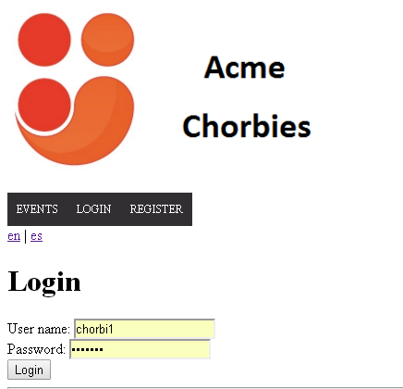

and select My events list option in menu bar,

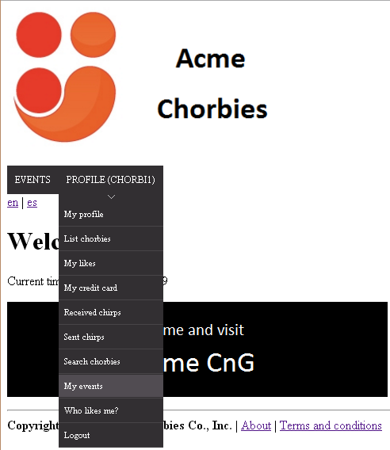

view that he or she´s registered in those events.

Tests

|  |  |
| --- | --- |
| **Test <#1>** | |
| **Description** | Browse his or her list of events |
| **Expected** | You have access to view your events list |
| **Outcome** |  |
| **Notes** |  |

# Use case 18 Update monthly fees

Description

Run a process to update the total monthly fees that chorbies would have to pay.

Access

Login as administrator

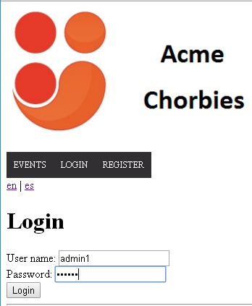

and select update chorbies fees in menu bar.

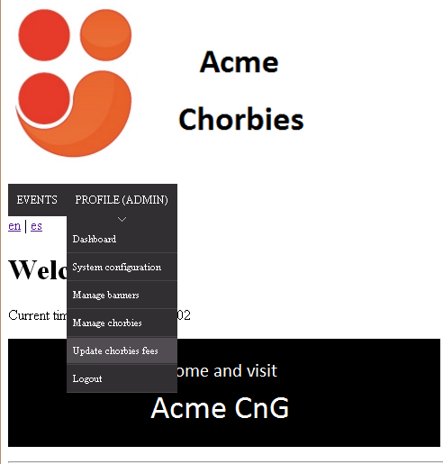

Tests

|  |  |
| --- | --- |
| **Test <#1>** | |
| **Description** | Upload monthly fees |
| **Expected** | The fee has been added to the corresponding chorbies |
| **Outcome** |  |
| **Notes** |  |

# Use case 19 Broadcast chirps

Description

Broadcast a chirp to the chorbies who have registered to any of the events that he or she manages

Access

Login as manager

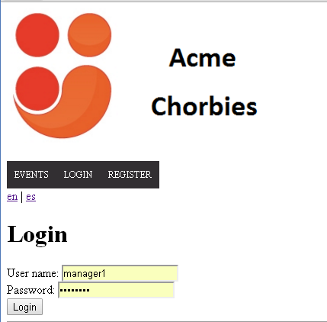

and select my events option in menu bar.

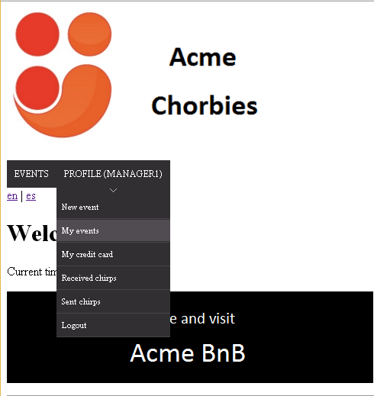

Then click in the option to send broadcast chirp.

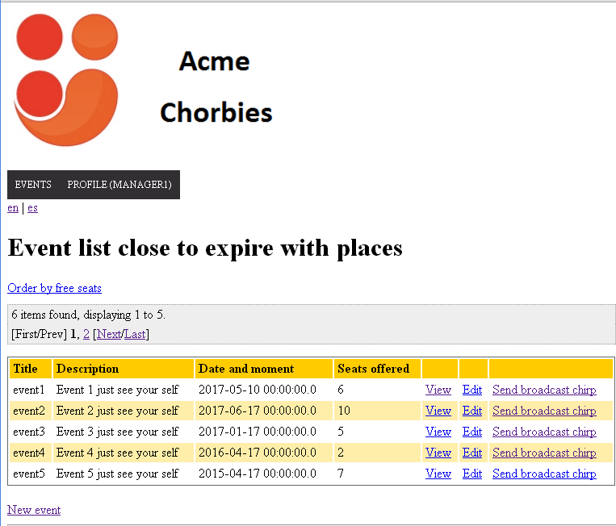

Tests

|  |  |
| --- | --- |
| **Test <#1>** | |
| **Description** | Broadcast chirps to the chorbies of any of the events that he or she manages |
| **Expected** | The chirps has been sent to the chorbies who are registered in the event |
| **Outcome** |  |
| **Notes** |  |

|  |  |
| --- | --- |
| **Test <#2>** | |
| **Description** | Send the chirp with all fields blank. |
| **Expected** | Errors will appear at each field with annotations about the errors. |
| **Outcome** |  |
| **Notes** |  |

# Use case 20 List of Chorbies who have liked him or her

Description

Browse the list of chorbies who have liked him or her as long as he or she has registered a valid credit card

Access

Login the application and select who likes me in the menu bar.



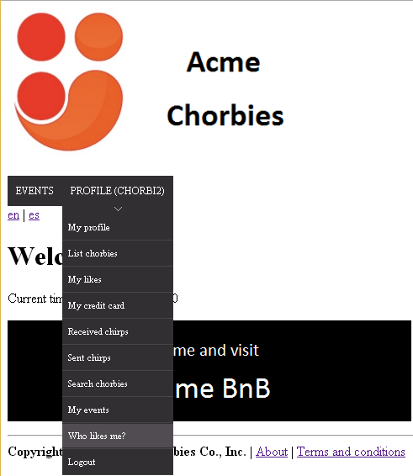

Tests

|  |  |
| --- | --- |
| **Test <#1>** | |
| **Description** | Browse the list of chorbies who have liked him as long as he or she has registered a valid credit card |
| **Expected** | A list of chorbies who have registered liked him or her. |
| **Outcome** |  |
| **Notes** |  |

|  |  |
| --- | --- |
| **Test <#2>** | |
| **Description** | Browse the list of chorbies who have liked without a valid credit card |
| **Expected** | “You do not have a credit card. You need one to search chorbies, see who likes you or create events. You card won´t be charged.” |
| **Outcome** |  |
| **Notes** |  |

# Use case 21 Manage credit card

Description

Manage his credit card, which includes registering, modifying, and deleting it.

Access

Login as manager or chorbie



and select my credit card option in menu bar.

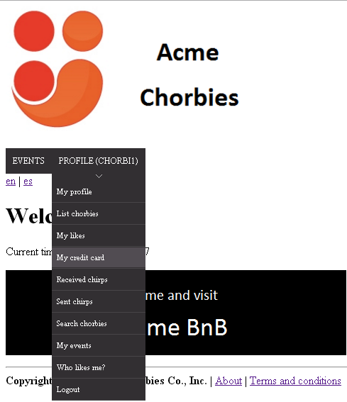

Tests

|  |  |
| --- | --- |
| **Test <#1>** | |
| **Description** | Register a new valid credit card. |
| **Expected** | Credit card has been created correctly |
| **Outcome** |  |
| **Notes** |  |

|  |  |
| --- | --- |
| **Test <#2>** | |
| **Description** | Modify a credit card with valid information, clicking in the button at the bottom of your credit card information |
| **Expected** | Credit card has been modified correctly |
| **Outcome** |  |
| **Notes** |  |

|  |  |
| --- | --- |
| **Test <#3>** | |
| **Description** | Delete a credit card |
| **Expected** | Credit card has been deleted correctly. |
| **Outcome** |  |
| **Notes** |  |

|  |  |
| --- | --- |
| **Test <#4>** | |
| **Description** | Register a new credit card with blank fields |
| **Expected** | Errors will appear at each field with annotations about the errors. |
| **Outcome** |  |
| **Notes** |  |